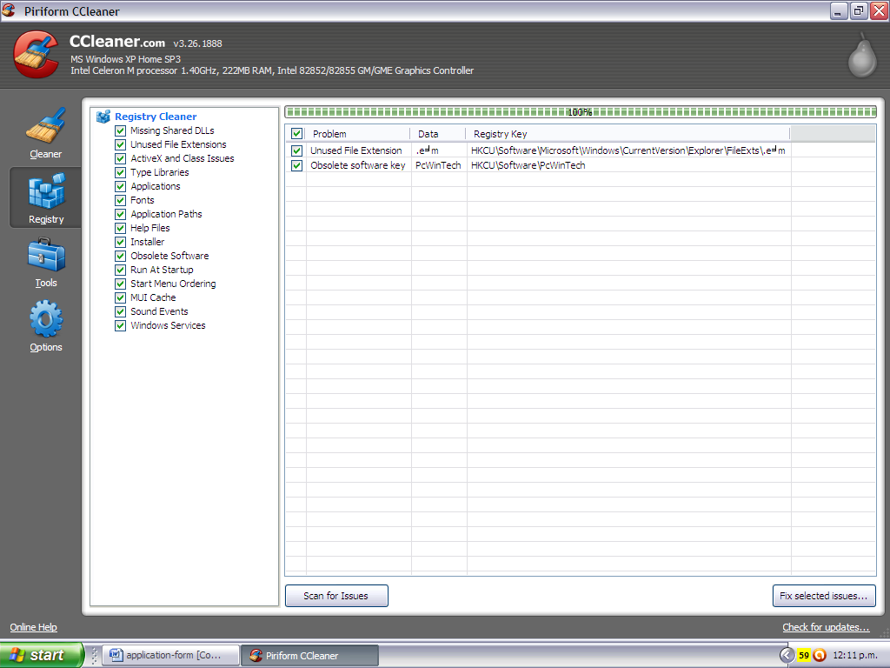

- I tried to save a Word document a error saying couldn’t save due to a file permission error popped up.

