Virtual computer, Win 7 ultimate x64, running on ESXi server v5.1. Set for 2 processors 4GB of ram, 100GB hard drive space (VDI). For the recorded session I set it for 1 processor, 4GB of ram, in hoping to slow the screens down.
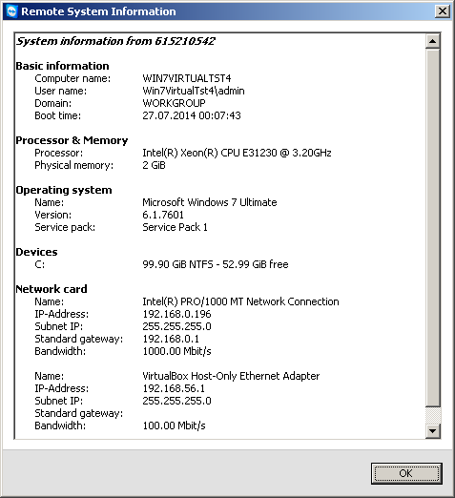

I ran a VMware snapshot prior to running it this time.
Uninterrupted Windows Repair (All in One) set for automatic restart when complete.
This is a new screen to me, as of v2.8.3
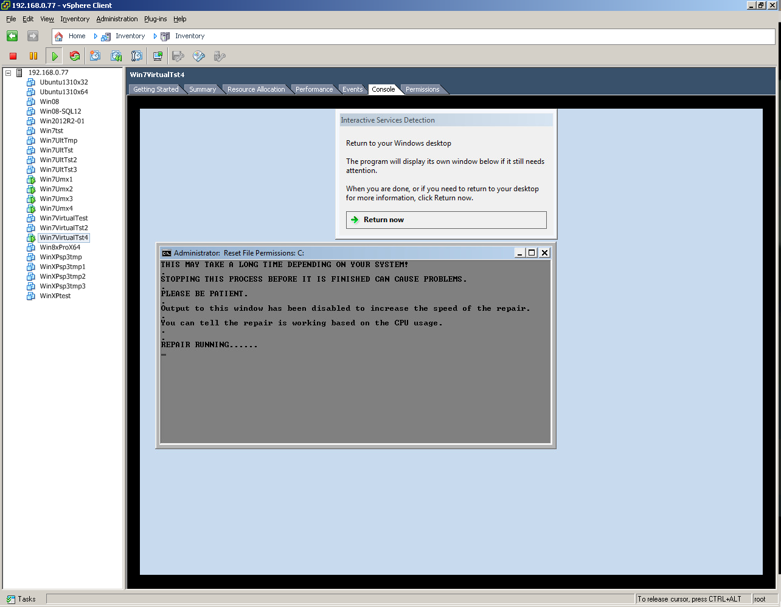
It then went to the Win7 lockout screen, even though I do not have it set to use it, even through a power scheme shutdown.



I can’t see that I’ve seen this ‘too long’ message in prior versions of Windows Repair
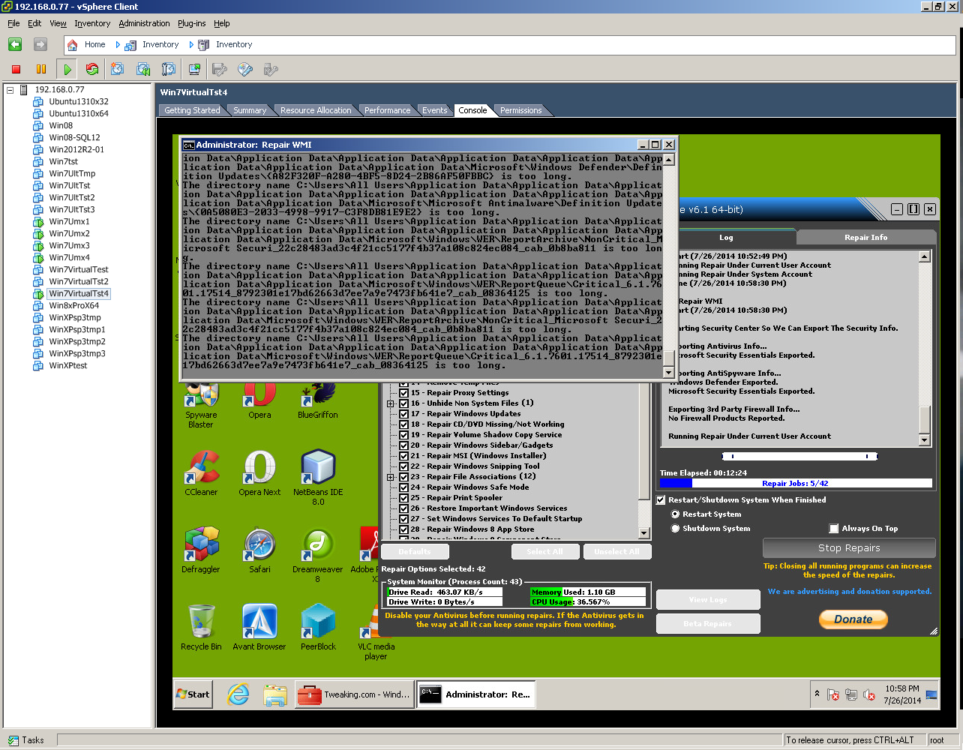

Following reboot, then trying to launch Oracle VM Virtual Box


Expanding the error – according to Internet sites the error means that it cannot find the virtualbox.exe


Shortcut properties for Oracle Virtual Box
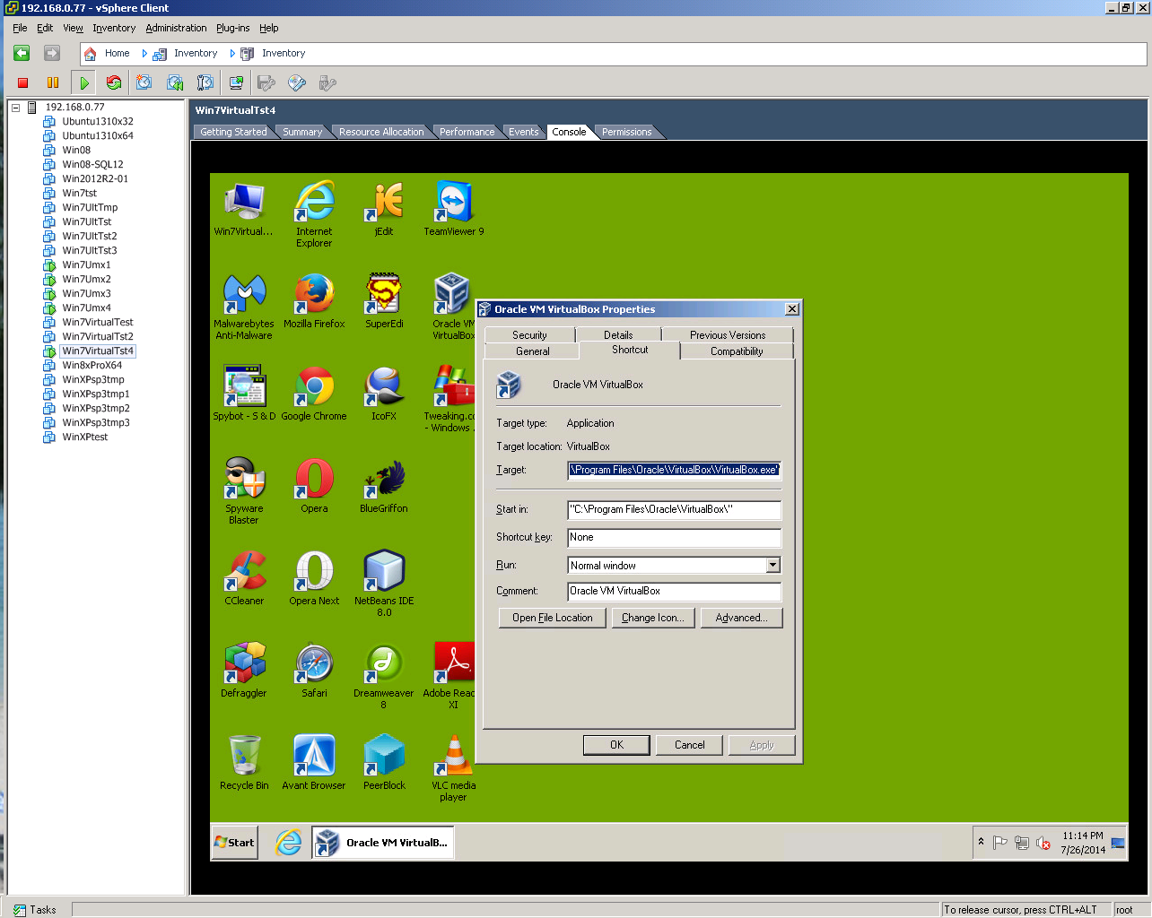

The evil recursive directory structure has returned.
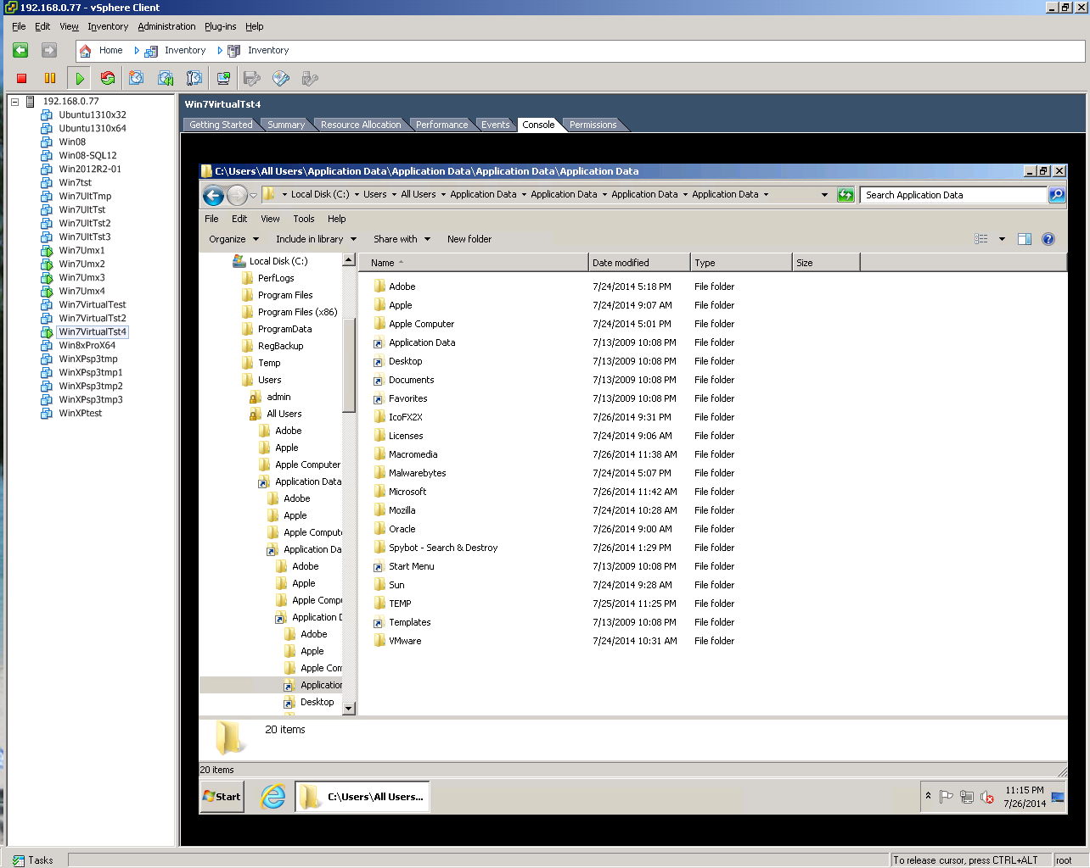

Oracle VirtualBox acted properly following VMware snapshot restore, and reboot.

